Problem Statement
A city bus or metro service sells tickets on several routes to different passenger categories (adult, student, senior citizen, child). Each category pays a different fare. At the end of the day, the cash and digital money collected should equal the revenue expected from the tickets issued. In practice the two often differ because of wrong fares, missing entries or errors.
Objectives
- Store route fares and category discounts in dictionaries.
- Store ticket records as tuples in a list.
- Calculate the fare for each passenger and the expected revenue per route.
- Compare expected and collected revenue for every route.
- Flag each route as MATCH, SHORTAGE or EXCESS.
- Detect and report invalid ticket records (unknown route or category).
Assumptions
- Each ticket record is a tuple: (route, category, passenger_count).
- Each route has a base fare per passenger: R1 = Rs 20, R2 = Rs 35, R3 = Rs 50.
- Category fare = base fare × multiplier, where the multipliers are Adult 1.0, Student 0.5, Senior 0.6 and Child 0.0 (free). These are example values.
- Collected revenue is given per route as a dictionary.
- Differences of up to Rs 1 count as a match (to allow for rounding or small change errors).
- Shortage means collected < expected. Excess means collected > expected.
- Tickets with an unknown route or category, or a negative passenger count, are invalid and are listed separately, not counted in the revenue.
Algorithm
- Define the base fares, category multipliers and tolerance.
- Read the ticket list and the collected revenue.
- For each ticket, calculate the fare per passenger (base fare × multiplier).
- If the route or category is unknown (or the count is negative), save the ticket in the invalid list and skip it.
- Otherwise add fare × passenger_count to that route’s expected revenue.
- For each route, calculate difference = collected − expected.
- If |difference| <= tolerance, status is MATCH. If the difference is negative, status is SHORTAGE. Otherwise it is EXCESS.
- Print the reconciliation report, totals and invalid tickets.
Pseudocode
base_fares = {R1: 20, R2: 35, R3: 50}
discounts = {Adult: 1.0, Student: 0.5, Senior: 0.6, Child: 0.0}
tolerance = 1

FUNCTION calculate_fare(route, category):
IF route not in base_fares OR category not in discounts:
RETURN None
RETURN base_fares[route] * discounts[category]

FUNCTION calculate_expected_revenue(tickets):
expected = 0 for every route
invalid = empty list
FOR each (route, category, count) in tickets:
fare = calculate_fare(route, category)
IF fare is None OR count < 0:
add ticket to invalid
ELSE:
expected[route] = expected[route] + fare * count
RETURN expected, invalid

FUNCTION reconcile(expected, collected):
FOR each route:
diff = collected[route] - expected[route]
IF abs(diff) <= tolerance: status = "MATCH"
ELSE IF diff < 0: status = "SHORTAGE"
ELSE: status = "EXCESS"
add (route, expected, collected, diff, status) to report
RETURN report

MAIN:
expected, invalid = calculate_expected_revenue(tickets)
report = reconcile(expected, collected)
print report, totals, invalid tickets
Test Cases
# | Test | Input | Expected result
1 | Adult fare | R1, Adult | 20.0
2 | Student discount | R2, Student | 17.5
3 | Senior discount | R3, Senior | 30.0
4 | Child free | R1, Child | 0.0
5 | Unknown route | R9, Adult | None (invalid)
6 | Unknown category | R1, VIP | None (invalid)
7 | Expected revenue | R1: 2 Adults + 2 Students | R1 = 40 + 20 = 60.0
8 | Empty ticket list | [] | All routes 0, no invalid tickets
9 | Exact match | Expected 100, collected 100 | MATCH
10 | Within tolerance | Expected 100, collected 99.5 | MATCH
11 | Shortage | Expected 100, collected 80 | SHORTAGE (−20)
12 | Excess | Expected 100, collected 130 | EXCESS (+30)
13 | No collection entry | Expected 100, collected missing | SHORTAGE (−100)
Output
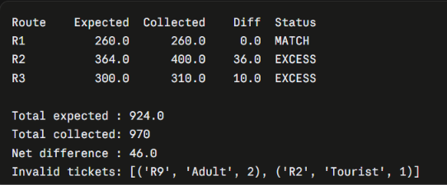
Flowchart
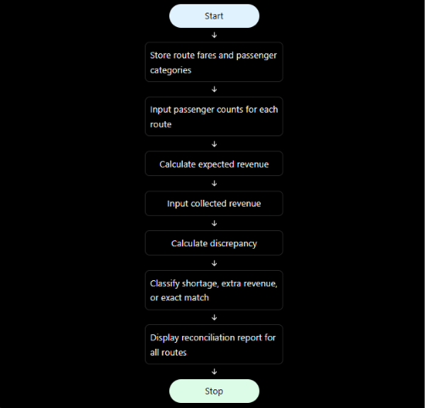
Conclusion
The program calculates passenger fares for each route and category, adds them up to get the expected revenue, and compares this with the revenue actually collected. It flags every route as MATCH, SHORTAGE or EXCESS and lists invalid ticket records. In the sample run, R1 matches, while R2 (Rs 36) and R3 (Rs 10) show excess collection. A real operator would investigate these, for example for unrecorded tickets or wrong fares charged. The invalid tickets (R9 and the “Tourist” category) are also listed for checking.

